Section 1 - Chart Of Accounts

1.1 Introduction
The previous COA required modification not only to provide for the recording of transactions in a PBB environment but also to ensure compliance with the IMF reporting requirements based particularly on the Government Finance Statistics (GFS) 2001.

The previous COA had a coding system aligned only to economic classification whereas what is required is a new coding system that is also aligned to programme and sub-programme. Also, the previous COA carried an economic classification not sufficiently detailed to the lowest activity, whereas we need a well-detailed economic classification, which facilitates the costing of programmes, sub programmes and outputs.

The new COA provides for an enhanced management information system for better decisions leading to a more efficient utilisation of resources.

1.2 Methodology
A COA working group (COAWG) comprising Officers of the Treasury, Budget Office, Finance and Internal Control Cadres, Central Statistics Office and National Audit Office was set up by MOFED to review the COA with a view to ensuring compatibility with the requirements of a PBB System.

Contributions were also obtained from IMF-FAD and UNDP international consultants during the design stage of the COA structure.

The aim of the COAWG was to develop a COA that is not only GFS compliant but also adheres to international best practice. Consideration has also been given to long-term efficiency at the expense of short-term comfort. In this respect, for instance, the values of some of the segments have been modified from an alpha mode to a numeric mode.

The Working Group is expected to be a standing committee to ensure that the new COA used as of 1st July 2008, is in line with best international practices and complies with international reporting standards. The working group is also responsible for the coding of new items.

  - Purpose
The purpose of the COA is to provide meaningful management information to enable users to analyse financial data both for internal and external reporting purposes. All reports require different presentation of information and the COA is used to collect the necessary data for manipulation.

The COAWG has adopted the approach of simplicity for the COA. The number of values in each segment will be kept to a minimum to enable ease of use, consistency and comparability.

1.4 Structure Of The Chart
A basic understanding of the COA as well as reporting segments and “roll-ups” is required to be able to use reporting tools effectively. The Chart is made up of the following 8 segments with each segment containing the number of digits or characters as indicated below.

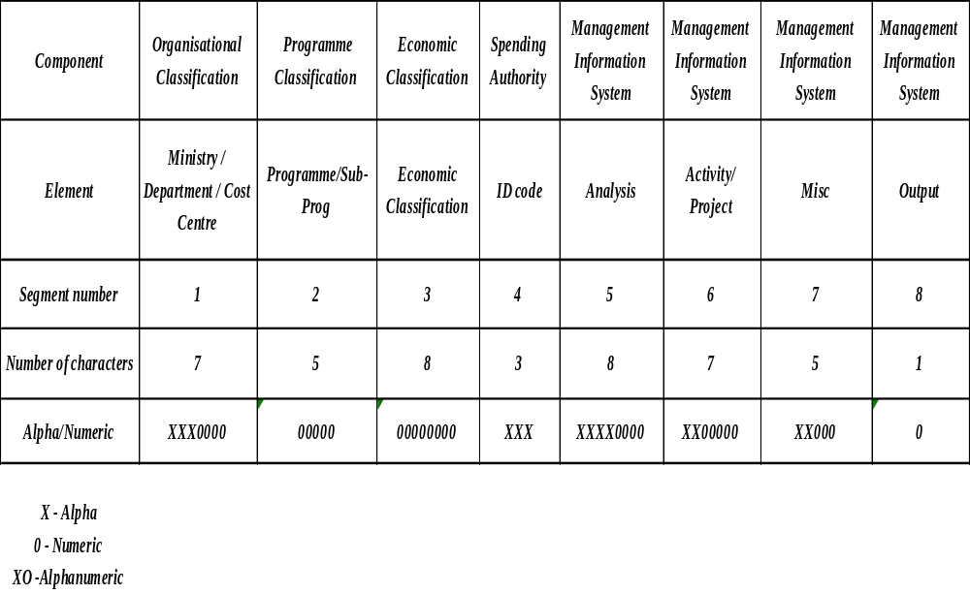

1.4.1 Organisational Classification

Organisational classification provides the basis for establishing the responsibilities for the day-to-day administration of government business. The structure of the organisational hierarchy is reflected in the series of codes for Ministries and Departments reporting under these Ministries.

1.4.2 Programme Classification
Programme/Sub-programme classification provides the basis for recording transactions associated with a specific programme and sub-programme delivered under an organisational unit.

1.4.3 Economic Classification
Economic classification provides the basis for recording specific activity by the kind of transactions by which the Government performs its functions and the impact outside the Government in the market for goods and services, and in the distribution of income. The item classification is consistent with definitions in the analytical framework of the Government Finance Statistics (GFS) Manual.

1.4.4 Functional Classification
The COA also provides for the functional classification of expense based on the United Nations Classification of Functions of Government (COFOG). COFOG is a detailed classification of the functions, or socio-economic objectives, that Ministries/Departments aim to achieve through various kinds of outlays.

A functional classification organises government activities according to their purpose (agriculture, defence, education, intergovernmental transfers, etc.) and is independent of the government’s organisational structure. This classification provides for the analysis of the allocation of resources among sectors and is important for monitoring macro budget policy objectives.

The system provides for an automatic allocation of sub-programmes to sub-functions of government as per the COFOG standard. For this purpose, the oracle tool called the Financial Statement Generator (FSG) is used. Sub-programmes are mapped to their corresponding sub-functions, thus allowing for each transaction to be captured under their appropriate function code. Accordingly, users would not need to allocate, at input stage, each and every transaction to respective functional codes.

1.5 Description Of Segments

1.5.1 Segment 1 – Organisational Classification

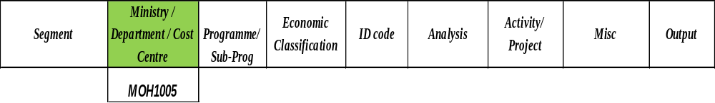

This segment identifies the Ministry in the first 3 characters e.g. MOH and provides for cost centres in 4 characters.

E.g. MOH 1005 identifies Region 1 and Area Health Centre No 5 of Ministry of Health and Quality of Life (Dr Boloux AHC see below)

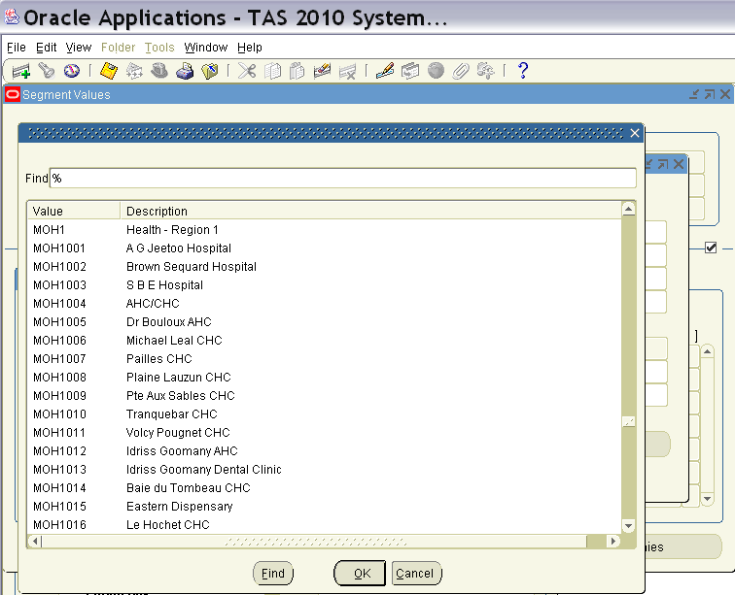

It is important for the COA to recognise only one code as representing a specific Ministry/Department to enable in year comparisons, thus the use of alpha codes is more appropriate.

Four numeric characters are being provided to designate a cost centre. Users will need to design their cost centre codes to fit into the length of the segment provided.

A list of values for Segment 1 is at Annex I.

1.5.2 Segment 2 – Programme/Sub-Programme

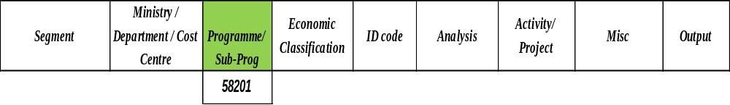

This segment identifies the programme (first 3 characters) and Sub-programme (next 2 characters) of Government. The programme code will be a standard unique code across Government. Each spending agency will be allocated a range of program codes over a period of years. For example, the Ministry of Health and Quality of Life will be allocated the programme code range of 581 to 600(see below). In case a programme or a sub-programme is entrusted to another Ministry it will retain the same code.
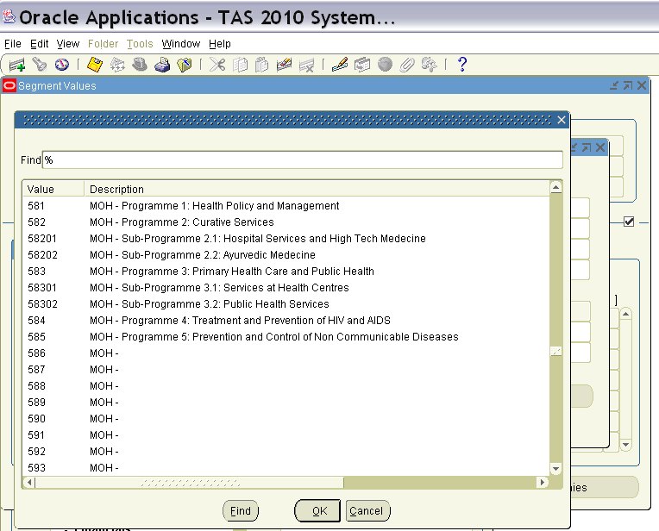

E.g. The code 58201 means Programme 582, Sub-programme 01 of the Ministry of Health and Quality of Life.

Virtual programme codes have also been allocated to revenue and below -the -line items to facilitate users task in extracting financial reports in respect of a category of items (see screen shot below).

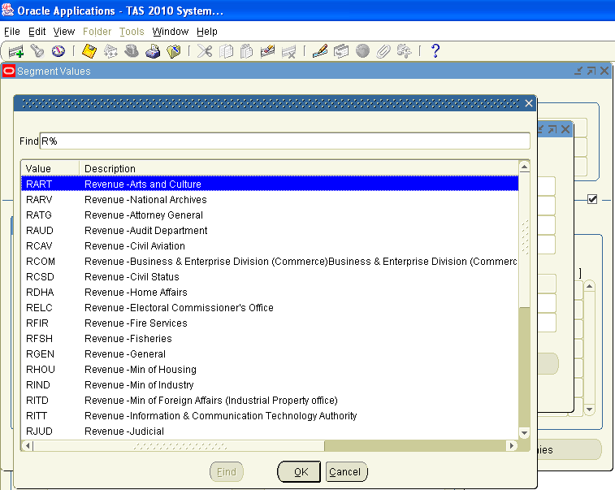

A list of programmes/sub-programmes is at Annex II.

1.5.3 Segment 3 – Economic Classification

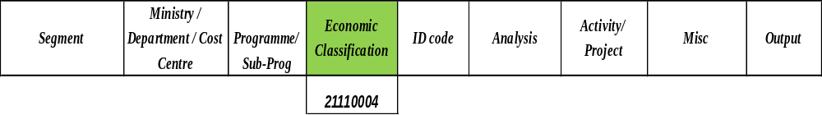

The Economic classification provides the basis for recording specific activity by kind of transaction by which the Government performs its functions. This segment identifies the specific items of revenue, expenditure, assets, liabilities and equity, which are aligned to the requirements of the 2001 GFSM.
E.g.
11110001 refers to Income Tax- Individuals
21110001 refers to Basic salary
31121801 refers to Acquisition of Transport Equipment
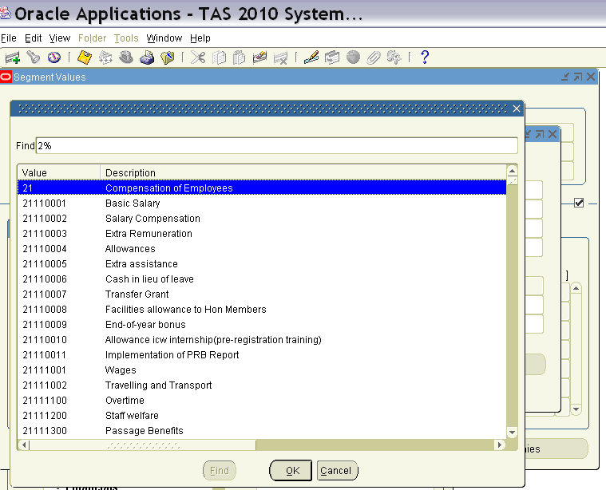

This segment consists of 8 characters providing the following:

First 5 characters: Economic Classification of Expense e.g 21110 represents Personal Emoluments

Next 3 characters: Element of Expense e.g 004 represents Allowances.

N.B The same coding structure is applicable to revenue and below-the-line items.

A list of items relating to revenue, expenses, assets, liabilities, funds and other below the line accounts, is at Annex III. The lists annexed herein include items existing as of the date of publication and will be updated on a quarterly basis.

1.5.4 Segment 4 – ID Code

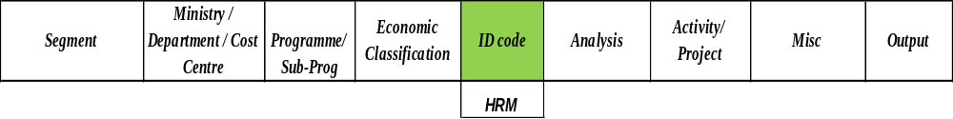

The ID Code is included in the COA for the identification of the authority granted by one Department (issuing Department) to another Department (recipient) to incur expenditure on the issuing Department’s behalf by way of a Departmental Warrant.

In general, the same codes designating an organization (e.g. HRM) will be used to designate the recipients.

The ID code is also used in cases where the budget for the programme/subprogramme of the Ministry/Department is under the control of more than one Accounting Officer. In such cases a different ID code is allocated to each Accounting Officer. Each Accounting Officer (designated by the Minister under the Finance & Audit Act) is allocated a different ID code as indicated at Annex IV.

In some cases, the budget in respect of a programme/subprogramme is, for administrative convenience, broken down into separate budgets. For example, in the case of MOEHR, the budgets for Programme 423 (Primary Education) and 424 (Secondary Education) have been split zone wise into sub-budgets although there is only one Accounting officer for all its programmes. To facilitate budgetary control at the level of such Ministries/departments a separate ID code is allocated in respect of each zone, Region, Embassy, etc.

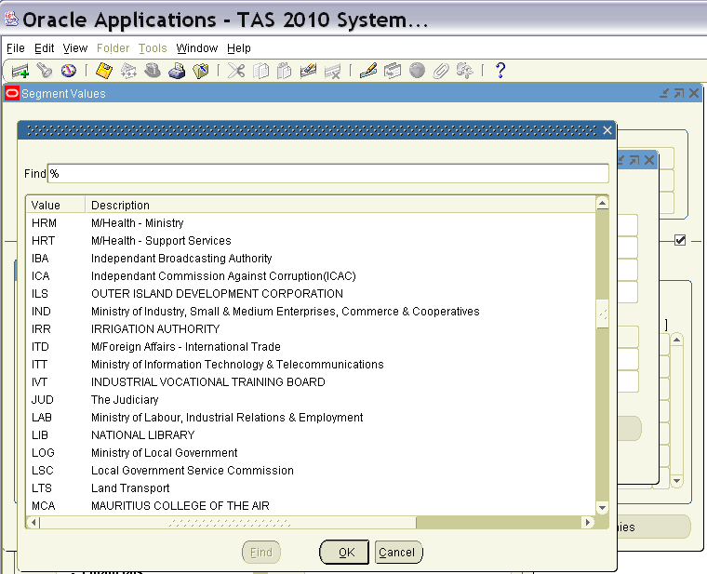

The relevant list of ID Codes is at Annex IV.

1.5.5 Segment 5 - ANALYSIS

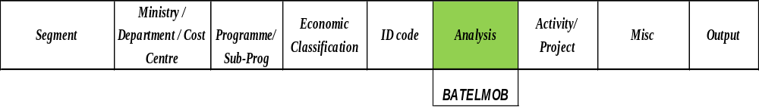
This segment provides for an independent detailed analysis code that is associated to one or more item codes under economic classification and provides for further detail on items of revenue and expense, should such detail be required.

E.g.
Allowances with item classification 21110004 can be further analysed into ad hoc, acting etc, thus each analysed item will bear an alpha, numeric or alpha numeric code

The analysis segment consists of 8 characters providing the following:

First character : Denotes the 2 digit economic class of the item eg B for 22 Goods and Services

Second character : Denotes the economic class of the item e.g BA for 22010 Cost of Utilities

Next 3 characters : Denotes the economic classification of the item e.g. TEL for telephone

Last 3 characters : Denotes the analysis of the item classification eg MOB for Cellular and FIX for Fixed line

N.B. A numeric coding structure is used for revenue and below-the-line items. As regards allowances under the ‘Compensation of Employees’ class, an alpha numeric coding structure is used in conformity with CISD codes for payroll purposes.

The following analysis code designates the full code in respect of the charges for cellular phone:
BATELMOB

NOTE: Where no analysis is required in respect of a budgeted expense item, revenue item or below the line item, default values should be used in lieu of analysis codes. The default values are as follows-
- expense item : 0
- revenue item : 0001
- below the line item : 0001

A list of analysis codes is at Annex V.

1.5.6. Segment 6 – Activity / Project

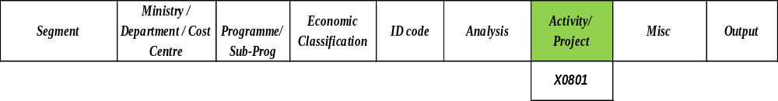

This segment is for the identification of all activities and projects managed and implemented by spending agencies. An activity is action taken or work performed

through which inputs such as funds, technical assistance and other types of resources are mobilized to produce specific outputs which is of a recurring nature (eg
Seminar). Project is defined as a collection of tasks aiming to achieve a certain goal and are of capital nature (eg Construction of Schools).

Some Ministries/Departments had in their budget items which encompassed more than one economic item of expense. Examples are:

Item “Promotion of Educational and Scientific Exchanges” under the vote of the Ministry of Education and Human Resources.

Item ‘National Assembly Election’ under the vote of the Electoral Commission Office

Such items do not appear in the new GFS compliant economic classification of items. Rather, the relevant items of expense under these “activities” would need to be captured. The relevant Ministries/Departments should maintain records of expenses incurred under such “activities”. For instance, the activity ‘National Assembly Elections’ would be assigned the code X0801

For capital projects the Public Sector Investment Programme (PSIP) codes should be used (refer to Annex VI). Below is a screen shot of how it appears in TAS.

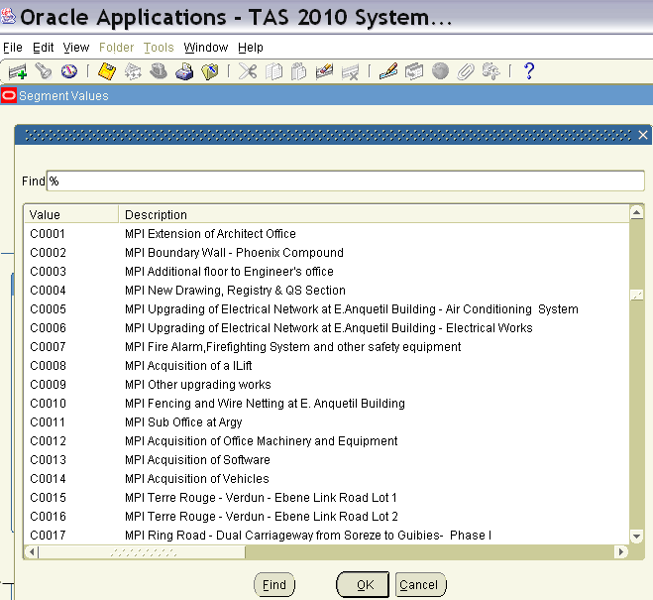

Ranges starting with letter ‘X’ have been used and each Ministry/Department has been allocated ranges of 100 activity codes. For example Electoral Commission Office has been allocated the range ‘ X0801 – X0900’.

This segment is used to capture financial data on activities which cut across Ministries/Departments. For instance, various Ministries/Departments may incur expenditure on activities geared towards poverty alleviation. Although each Ministry/Department will use a separate code in respect of its own activity or activities, the system (through the FSG facility) will enable the capture of total expenditure on poverty alleviation.

Below is a screen shot of how activity codes are registered in TAS.

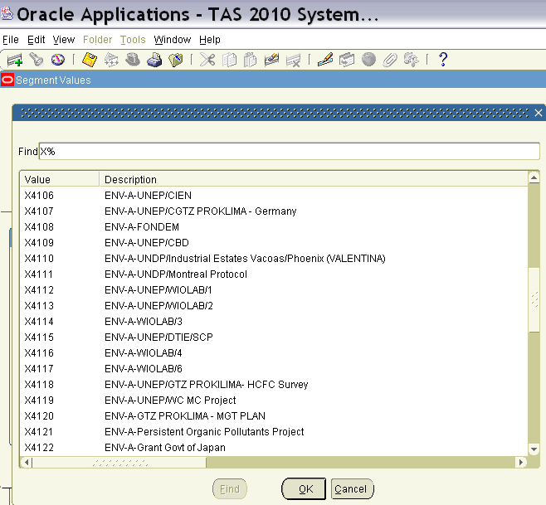

A list of activity and project code is at Annex VI.

1.5.7 Segment 7 - Miscellaneous

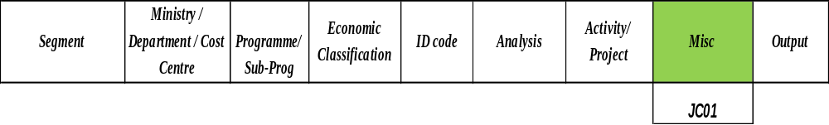

This segment enables the capture of information such as names, gender and classes of beneficiaries, and also provides for the recording of geographic data.

The segment has an alphanumeric coding structure which consists of 5 characters . Miscellaneous codes are allotted to Ministries/Departments on request.

1.5.8 Segment 8 – Output

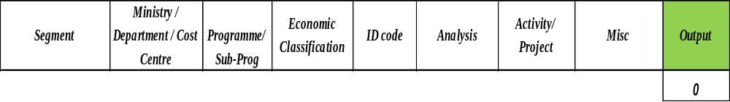
This segment enables the capture of data on outputs and has a default value ‘0’.
.

Section 2 - Items Classification

2.1 Overview
The voluminous mass of transactions in Government necessitates the classification of items of revenue and expense in a systematic and logical manner that helps to record the financial transactions and also facilitates the retrieval of information and generation of reports.

The Government Finance Statistics (GFS) Manual 2001 of the International Monetary Fund (IMF) provides guidelines for the classification of Government’s financial transactions. With a view to promoting consistency and comparability, the IMF has requested all its member countries to prepare and present financial statements as per GFS Manual 2001.

2.2 Revenue
The main sources of revenue of the Government are: income from different types of taxes imposed, Grants, interest on loans granted to Statutory/ Private Bodies and Private Individuals, property income, and sales of goods and services.

As per GFS Manual 2001, revenues are classified according to different characteristics depending on the type of revenue. Revenue from taxes is classified according to the base on which the tax is levied. Grants are classified by the source from which they are derived and property income is classified by the type of income. The revenues of the Government of Mauritius have been classified as illustrated in Table 1 below:
Table 1: Classification of Revenues
Code | Revenue | Code | Revenue
11  111  112  113  114  115  116 | Taxes:  Taxes on income, profits and capital gains  Taxes on payroll and workforce  Taxes on property  Taxes on goods and services  Taxes on international trade and transactions  Other taxes | 13  131  132  133 | Grants:  From foreign Governments  From international organisations  From other general Government units
12  121  122 | Social contributions:  Social security contribution  Other social contributions | 14  141  142  143  144  145 | Other revenue:  Property income  Sales of goods and services  Fines, penalties and forfeits  Voluntary transfers other than grants  Miscellaneous and unidentified revenue

In the table above only the main sources and types of revenue have been shown. However, a more detailed list of classified revenues is provided at Annex III Part 1.

The format for the classification of revenues as required by the IMF has been adapted as far as possible in the table above to reflect the main sources of revenues generated by the Government of Mauritius. A complete format of revenue classification of the GFS manual is provided at Appendix A.

2.2.1 Taxes
Tax is the major source of revenue of the Government of Mauritius. Taxes are imposed on incomes, profits, capital gains, property, goods and services, international trade, etc. Revenues collected from these taxes have been grouped as follows:

      - Taxes on income, profits and capital gains
Taxes on income, profits and capital gains are attributed to individuals, corporations and other enterprises and are imposed on:
- Wages, salaries, fees, commission, fringe benefits and other compensation paid to workers, employees, managers, public officers, directors, board members, members of parliament, ministers, etc;
- Interests, rent and royalty incomes received by both individuals and corporations;
- Capital gains realised on the sales of land, buildings and other properties; and
- Profits of companies and body corporates.

Under this category tax deducted at source is included. e.g tax on rental payments, payments made to contractors/Sub-contractors and others..

      - Taxes on Payroll and Workforce
Under this category, taxes are collected from employers or self-employed either as a proportion of payroll size or as a fixed amount per person and that are not earmarked for social security schemes.

Payments made for social security schemes are classified as ‘Social Security Contributions’.

      - Taxes on Property
It applies on the use, ownership or transfer of wealth and is collected at regular intervals, one time only, or on a change in ownership.

It includes taxes imposed on
- Immovable property such as Land Transfer Tax, Registration Duty on transfers, Land Conversion Tax, Morcellement Fee, Campement Tax, etc.

- Financial and Capital Transactions which comprise of Registration Duty on Loans; Fixed and Floating Charges; Transfer of Shares; Mortgages, Inscriptions and Transcriptions; and Stamp Duties.

- Other recurrent tax on Property such as Registration Duty on transfer of Motor Vehicles, other movable property and lease of movable property.

      - Taxes on Goods and Services
This category includes all taxes levied on the production, extraction, sale, transfer, leasing, or delivery of goods and rendering of services. It also includes taxes on the use of goods and on permission to use goods or perform activities.

It comprises :
- General Taxes on goods and Services such as Value Added Tax (VAT) and Turnover and other General Taxes.

- Excise Duties on spirits, liquors and alcoholic beverages, tobacco products, motor vehicles and motor cycles, and petroleum and plastic products.

- Taxes on Specific Services such as lotteries, betting, gaming and passenger fee.

- Taxes on Permission to Use Goods or Perform Activities e.g Road Motor Vehicle Licences, Company Licences, Incorporation and Lodging Fees, Search Duty, Tourist Enterprise Licences, Gaming Licences, Liquor Licences, Sugar Brokerage Tax, etc.

2.2.1.5 Taxes on International Trade & Transactions
Under this heading, customs and other import duties collected from goods imported to Mauritius are recorded.

2.2.1.6 Other Taxes
All taxes collected that do not fit under the above categories are recorded under this heading. It includes revenue items like, Temporary Solidarity Levy, Environment Protection Fee, Special Levy on Banks and Special Contribution from Hotel Sector.

2.2.2 Social Contributions
Social contributions are receipts either from employers on behalf of their employees or from employees, self-employed, or non-self employed persons on their own behalf that secure entitlement to social benefits for the contributors, their dependents, or their survivors. These contributions may be voluntary or compulsory

It also includes contributions to Civil Service Family Protection Scheme and Retiring Allowance Scheme for Members of the National Assembly.

2.2.3 Grants
Under this classification, grants of both capital and current nature received from foreign Governments, International Organisations and Other General Government Units are recorded.

2.2.4 Other Revenue
Other revenue includes the following:

      - Property Income
It includes interest received from loans issued to Statutory/Private Bodies and Private Individuals, dividends from Corporations in which the Government is a shareholder and rental income from Campement Site Lease and lease of other Government buildings.

It also includes ‘Transfer of Surplus Balances’ for Government Lotteries, Gambling Regulatory Authority, Wastewater Management Authority, Information & Communication Technology Authority, Treasury Foreign Currency Management Fund, Financial Services Commission and Mauritius Ports Authority.

      - Sales of Goods & Services
It comprises of:
- Sales by market establishments

Market establishments are Units/Divisions of Public Corporations situated at single location that sell or dispose their produce/output from their principal activity at economically significant prices.

All sales by these Units/Divisions are included under this category.

- Administrative fees
This item includes fees collected for administrative services. Examples are court fees, fees for issue of National Identity Cards, duty on scales, fees for import permits, parking fees, issue of passports, fees for Police services, fees for veterinary services, fees for import permits, vaccination fees, route air navigation charge, fees for celebration of civil marriage, etc.

- Incidental sales by non-market establishments
It covers sales of goods and services by non-market establishments of general government units other than administrative fees. It includes sales incidental to the usual social or community activities of government Departments and agencies. Examples are sales of copies of judgement of the Supreme Court, sales of overseas news, sale of seeds, sales of plants, fruits and agriculture produce, sale of milk, sale of farm produce, etc.

      - Fines, penalties and forfeits
Fines and penalties are compulsory payments imposed by courts of law or quasi-judicial bodies for violations of laws or administrative rules. On the other hand, forfeits are amounts deposited with the Government pending a legal or administrative proceeding which have been transferred to the latter as part of the resolution of that proceeding.

The above are recorded when the general Government Units such as Judicial, Customs, National Transport Authority and the Treasury have a legal claim when a court renders judgement or an administrative ruling is published, or when a late payment or other infringement automatically causes a fine or penalty.

      - Voluntary transfers other than grants
Under this item voluntary transfers in the form of gifts and donations from individuals, private non-profit institutions, non-government foundations, corporations, and any other source other than Governments and international organisations are recorded.

Voluntary transfers can be classified as current or capital. Examples of Current voluntary transfers are provision of food, clothing, bread, blankets and other goods to hospitals, schools, etc. On the other hand, Capital voluntary transfers include transfers for the construction of hospitals, schools and other Government buildings; and gifts of land, buildings, or intangible assets such as patents and copyrights.

If however, there is difficulty in the classification of a voluntary transfer between current and capital, it is classified as current.

      - Miscellaneous and unidentified revenue
All revenues that do not fit in any other categories are recorded under this item.

2.3 Expenses
Expenses can be classified by Economic Classification and Functions of the Government.

2.3.1 Economic Classification of Expense
It identifies the types of expenses incurred for the Government activities. For example, compensation of employees, use of goods and services, social benefits, etc.

An adapted and simplified version of economic classification of expenses of the Government of Mauritius is provided in Table 2 below. For a detailed economic classification of the expenses as required by GFS manual, please refer to Appendix B.

Table 2: Economic Classification of Expenses
Code | Expense | Code | Expense
21  211  2111  212  2121 | Compensation of Employees  Wages & Salaries  Wages & Salaries in cash  Social Contributions  Actual Social Contributions | 26  261  26110  262  26210  26220  263  26310  26320 | Grants  To foreign Governments  Current  To international organisations  Current  Capital  To other general Government Units  Current  Capital
22 | Use of Goods & Services
24  241  242  243 | Interest  To non-residents  To residents other than general Government  To other general Government Units | 27  271  27110  272  27210  27220  273  27310 | Social Benefits  Social Security Benefits  Social Security Benefits in cash  Social Assistance Benefits  Social Assistance Benefits in cash  Social Assistance Benefits in kind  Employer Social Benefits  Employer Social Benefits in cash
25  251  25110  25120  252  25210 | Subsidies  To Public Corporations  To non-financial Public Corporations  To financial Public Corporations  To Private Enterprises  To non-financial Private Enterprises | 28  282  28210  28220 | Other Expense  Miscellaneous Other Expense  Current  Capital

2.3.1.1 Compensation of Employees
It is the total remuneration payable to Government employees in return for work performed. It comprises of wages and salaries in cash and social contributions.

Wages and salaries include basic salary, salary compensation, extra remuneration, allowances, extra assistance, cash in lieu of sick leave, transfer grant, facilities allowance to honourable members, end of year bonus, travelling & transport, overtime, passage benefits and allowance in lieu of passages.

On the other hand, social contributions include all contributions made by Government with respect to the ‘National Savings Fund’.

2.3.1.2 Use of Goods and Services
‘Use of goods and services’ include all items of expenses incurred by the Government in providing goods and services to the public and community at large.

It comprises of:
- ‘Cost of Utilities’ such as electricity and gas charges, telephone charges, water charges and waste water charges;
- ‘Fuel and Oil’ costs for Government vehicles (e.g cars, motorcycles, helicopters, ships and aircrafts) and plant and equipment;
- ‘Rent’ paid for buildings, parking slots, vehicles, equipment and facilities for events;
- ‘Office Equipment and Furniture’ (e.g chair, table, etc);
- ‘Office Expenses’ (e.g postage, cleaning materials, office sundries, etc);
- ‘Maintenance’ costs for building & other structures, plant & equipment, vehicles & motorcycles, IT equipment, furniture, helicopters, ships, aircrafts and grounds;
- cost of ‘Cleaning Services’ for public beaches, office premises, laundry, refuse collection, etc;
- ‘Uniforms’ e.g protective clothing, general clothing, etc;
- cost of ‘Security services’;
- ‘Publications and Stationery’ such as paper & materials, news service, printing & stationery, books & periodicals, public notices, publications and publicity;
- ‘Mission Expenses of Ministers and Delegates’ which includes subsistence allowance, cost of air tickets, hotel accommodation, travelling and other expenses of Ministers, Members of National Assembly, Officers, Consultants and other delegates;
- ‘Fees’ for Medical Boards and domiciliary visits, fees to Chairman and Members of Boards & Committees, fees in connection with Commission of Enquiry and Committee, fees for witnesses and assessors, fees to Consultants, etc;
- costs related ‘Studies and Surveys’ e.g costs of studies and preliminary project preparation, costs of surveys such as Continuous Multipurpose Household Survey, Household Budget Survey, Census, Tourism, etc;
- costs of ‘Medical Supplies, Drugs and Equipment’ payable by Ministry of Health & Quality of Life for hospitals, health centres and dispensaries such as apparatuses and laboratory supplies; CT scan and MRI fees and materials; dental materials and equipment; orthopedic materials and equipment; Ayurvedic and other traditional medicines; medical drugs and vaccines; etc;
- ‘Other Goods & Services’ such as clothing and bedding costs; boarding and lodging costs; cost of air tickets; catering; provision of meals and stores; school requisites; sport equipment; medals, prizes and rewards; insurance; entertainment; costs of Personal Secretariat of retired President/Vice President/Governor General; management/service charges; etc; and
- ‘Miscellaneous Expenses’ include
- Out of pocket allowances,
- Legal assistance to drivers,
- Anti doping test,
- Expenses icw access to sports facilities in secondary schools,
- Requisites for home economics training,
- Purchase of toys,
- Sponsorship of events,
- Entry permit fees
- Payment for analysis of industrial effluents,
- Purchase of ID Cards for students of legal council,
- Transcribers duties and
- Any other expenses which have not been classified under any heading of ‘Use of Goods & Services’.

2.3.1.3 Interest
Interest is payable by the Government for liabilities incurred in the financing of its day to day activities and capital projects such as construction of roads, dams, highways, schools and hospitals.

The activities and capital projects are currently being financed through:
- non-residents, in the form of external debt; and Treasury Bills and Notes
- residents, in the form of internal debt such as issue of Treasury Bills, Treasury Notes, Mauritius Development Loan stocks (MDLS), Bonds, Advances and Special Saving Scheme; and
- other general Government Units, in the form of internal debt such as Treasury Bill and Notes.

Internal debts are loans taken from local Banks and Financial Institutions. On the other hand, external debts are loans from foreign Government and Lending Agencies. Interests on these debts are payable on respective dates as stipulated by Loan Agreements.

On the other hand, interests on Treasury Bills are paid on maturity. In contrast, interests on Treasury Notes, MDLS and Bonds issued by the Government are paid on a half-yearly basis.

2.3.1.4 Subsidies
Subsidies are payments that Government makes to public and private enterprises on the basis of the levels of their production activities or the quantities/values of goods/services they produce, sell, export or import. These subsidies are provided with a view to boosting up domestic productions and also influencing the prices of goods/services that will be exported or have been imported for local consumption.

It also includes transfers to public and private corporations to compensate for losses they incur on their productive activities as a result of charging prices that are lower than their average costs of production as a matter of deliberate economic and social policy.

Subsidies are paid to the producer and not to the final consumers. Direct payments to final consumers or transfers through non-profit organisations or NGOs to consumers are treated as either ‘Social Benefits’ or ‘Miscellaneous Other Expense’, depending on the reason and purpose of the payments.

Subsidies may be classified by whether the recipient is a public or private organisation and whether it is financial or non-financial enterprise. This results in the following possibilities:
- Public Corporation
- Non-Financial Public Corporation
It includes transfers made to:
- Mauritius Meat Authority;
- Mauritius Shipping Corporation Ltd;
- National Transport Corporation for free travel to students ,old aged pensioners and disabled persons;
- National Housing Development Co. Ltd

- Financial Public Corporation
It includes subsidies to the Development Bank of Mauritius to operate schemes such as granting of loans for purchase of computers and to provide financial help to cow breeders.

It also includes subsidies granted to the Mauritius Housing Company Ltd to operate housing loan schemes.

- Private Enterprises
- Non-Financial Private Enterprise
It comprises of subsidies granted to:
- Private enterprises as incentives for the production of vegetables, fruits and livestock;
- Ferry Boat Operators;
- Private Bus Operators for free travel to students ,old aged pensioners and disabled persons.

- Financial Private Enterprise
Presently, no subsidy is being paid to financial private enterprises. However, in case Government decides to effect such transfer, it will be treated under this heading.

2.3.1.5 Grants
Grants are voluntary current or capital transfers from one Government Unit to another or an international organisation. It may be classified by the type of unit or organisation receiving the grant and whether the grant if current or capital.

Grants payable by the Government has been classified as follows:
- Grants to Foreign Governments
Presently, only current grants are provided to foreign Governments.

- Grants to International Organisations
Presently, no current grant is being paid by the Government to international Organisations. However, provision has been made to include these grants under the appropriate heading if they occur.

Capital grants are mainly subscriptions paid to international organisations such as African Development Bank, Common Market for Eastern and Southern Africa (COMESA), International Finance Corporation, Multinational Investment Guarantee Agency, International Bank for Reconstruction and Development (IBRD), etc.

- Grants to other general Government units
Both current and capital grants are paid to general Government units such as Rodrigues Regional Assembly; Municipal and District Councils; and Extra-Budgetary Units (EBUs) such as Apravasi Ghat Trust Fund, Mauritius Examination Syndicate, etc.

2.3.1.6 Social Benefits
Social benefits are defined as transfers in cash or in kind to protect the entire population or specific segments of it against certain social risks.

A social risk is an event or circumstance that may adversely affect the welfare of households concerned either by diminishing their resources or by reducing their incomes.

Social benefits include the provision of basic retirement pension; social aid to fire, flood and cyclone victims; assistance to professional fishermen; etc.

These benefits can be classified as follows:
- Social Security Benefits
These are payable in cash or in kind to households by social security schemes. Examples of social security benefits in cash are sickness and invalidity benefits, children’s or family allowances, unemployment benefits, etc.

On the other hand, social security benefits in kind include goods and services provided to households or reimbursement of cost of purchases to households.

- Social Assistance Benefits
Social assistance benefits in cash include:
- payment of old aged pensions;
- social aids to victims of cyclone, flood and fire;
- unemployment hardship relief;
- assistance to professional fishermen in terms of bad weather allowance and close season allowance;
- income support for rice and flour;
- assistance to patients inoperable in Mauritius;
- assistance to parents of disabled children;

On the other hand, social assistance benefits in kind include the provision of hearing apparatus, spectacles, wheel chairs, dentures, etc.

- Employer Social Benefits
These are benefits payable by Government to its employees participating in the scheme or to survivors and dependents of the employees who are eligible for such payments.

Employer social benefits include National Assembly Retiring Allowances; pensions; gratuities to public Officers on retirement/death; gratuities to Officers on contract; and Compassionate Allowances.

2.3.1.7 Other Expense – Miscellaneous Other Expense
It includes a number of transfers made for different purposes, which have not been classified elsewhere.

These transfers can be classified as current or capital depending on the purpose for which they were made.

The current transfers have been classified as:
- Transfers to non-profit institutions
These include transfers to aided schools, charitable institutions, Religious bodies, local organisations, etc.

- Transfers to households
Transfers to households comprise :
- Compensation to net fishermen;
- Scholarships to foreign students;
- Scholarships to Mauritian students;
- Gifts to centenarians;

On the other hand, capital transfers have been classified as:
- Transfers to non-profit institutions
These include contribution for renovation of private primary schools, grants to organisations of disabled, etc.

Transfers to households
Capital transfers to households comprise costs of roof slabs; land and sites for social housing, etc.

- Transfers to non-financial public corporations
These transfers are payable to Enterprises Mauritius, National Housing Development Co. Ltd, among others.

- Transfers to financial public corporations
These include transfers to Development Bank of Mauritius .

- Transfers to private enterprises
These include for transfer in respect of accompanying measures to Small and medium Enterprises (SMEs) and Sugar sector.

2.4 Classification Of The Functions Of The Government
Classification of the functions of the Government (COFOG) provides information on the socio-economic objectives that the Government aims to achieve through various outlays and gives details on the purpose for which an expense was incurred. Examples are education, health and environment protection.

In line with Programme-Based Budgeting, programmes fulfilling the different functions of the Government through the Ministries/Departments have been identified. These programmes have specific objectives and expected results. All outlays relating to a specific programme are grouped together. This facilitates the measurement and monitoring the performance. A list of programmes together with the Ministries/Departments responsible for them, is provided at Annex II.

A detailed format of classification of expenses by functions of Government as required by the IMF is provided at Appendix C. This format has been adapted to reflect the functions of the Government of Mauritius which are as follows:
- General Public Services - 701;
- Public Order and Safety - 703;
- Economic Affairs - 704;
- Environmental Protection - 705;
- Housing and Community Amenities - 706;
- Health - 707;
- Recreation, Culture and Religion - 708;
- Education - 709; and
- Social Protection – 710.

General Public Services (701)
This category includes the following:
2.4.1.1 Executive and legislative organs, financial and fiscal affairs, external affairs (7011)
- The ‘executive and legislative organs’ (70111) include Office of the President, Office of the Vice-President, the National Assembly, the Prime Minister’s Office and Attorney General’s Office, Ministry of Justice & Human Rights.

- Under ‘Financial and fiscal affairs’ (70112) all expenses relating to operation of the treasury, budget office, accounting and auditing services are grouped.

The above functions are performed by the National Audit Office, the Treasury Department and the budget unit of the Ministry of Finance and Economic Development.

- External Affairs (70113)
It relates to the administration of external affairs and services and comprises of:
- operation of the Ministry of Foreign Affairs, International Trade and Cooperation;
- provision of diplomatic and consular services;
- international cooperation;
- regional cooperation and integration

These functions are being carried out by the Ministry of Foreign Affairs, International Trade and Cooperation.

2.4.1.2 General Services (7013)
General Services comprise of:
- General Personnel Services (70131)
It includes the administration and operation of general personnel services; development and implementation of general personnel policies and procedures such as selection, promotion, performance management, description and classification of jobs; and the administration of civil service regulations and similar matters.

Selection exercises are carried out by the Public and Disciplined Forces Service Commission (PDFSC) and the Local Government Service Commission (LGSC) in the public sector and local Government sector respectively.

On the other hand, the Ministry of Civil Service Affairs and Administrative Reforms is responsible for the administration of personnel services and civil service regulations and the setting up and monitoring of a Performance Management System.

All expenses incurred in the operation of the PDFSC, LGSC and the Ministry of Civil Service Affairs and Administrative Reforms are treated under this heading.

- Overall Planning and Statistical Services (70132)
The Central Statistics Office provides the overall statistical services. Thus, all expenses of this Office are included under the above category.

- Other General Services (70133)
It covers the provision of general services such as a centralised supply and purchasing service; maintenance and storage of Government records, Government operated printing office; and centralised computer and data processing services.

The above functions are respectively carried out by:
~ Central Procurement Office;
~ Ministry of Arts & Culture;
~ Government Printing Office; and
~ Ministry of Information Technology & Telecommunications

2.4.1.3 General Public Services (Not Elsewhere Classified)
It relates to general public services that have not been classified elsewhere such as registration of voters, holding of elections, administration of non-self–governing and trust territories, etc.

The function relation to elections is carried out by the Electoral Supervisory Commission & Electoral Boundaries Commission and the Electoral Commissioner’s Office.

The above category also includes the Outer Islands Development function of the Ministry of Rodrigues and Outer Islands.

    - Public Order and Safety (703)
It relates to public order and safety services provided by Government through:
- Police Services;
- Fire Protection services;
- Law Courts; and
- Prisons

2.4.2.1 Police Services (70310)
It relates to the administration of police affairs and services and includes services provided by the Police Department, Passport Office, Police band, Special Mobile Force, National Coast Guard and Helicopter Unit.

2.4.2.2 Fire Protection Services (70320)
It relates to the administration of fire prevention and fire fighting affairs and services.

These services are provided by the Fire Services Department of the Ministry of Local Government.

2.4.2.3 Law Courts (70330)
All expenses incurred in the administration, operation or support of civil and criminal law courts and the judicial system are treated under this heading.

It includes the operation of the Ombudsman’s Office, Permanent Arbitration Tribunal, Ombudsperson for Children’s Office, the Judiciary, and public prosecutions and courts services provided by the Attorney General’s Office, Ministry of Justice & Human Rights.

2.4.2.4 Prisons (70340)
It relates to the administration and operation of prisons. In Mauritius this function is undertaken by the Mauritius Prison Services.

All expenses relating to the above are treated under this heading.

2.4.2.5 Public Order and Safety (Not Elsewhere Classified) (70360)
It includes all other public order and safety functions carried out by Government, which have not been classified elsewhere.

The function of combating corruption by the Independent Commission Against Corruption is included here. Thus, all expenses relating to this function are treated under this category.

    - Economic Affairs (704)
This function covers a wide range of activities, which are being carried out by different Ministries/Departments.

It comprises of:
2.4.3.1 General Economic, Commercial and Labour Affairs (70411)
These relate to the general administration of economic, commercial affairs.

The above functions are carried out by the Ministry of Foreign Affairs & International Trade, Ministry of Industry , Small & Medium Enterprises, Commerce & Co-operatives and Ministry of Women’s Rights, Child Development, Family Welfare and Consumer Protection.

2.4.3.2 Agriculture, Forestry, Fishing and Hunting (70421, 70422 & 70423)
These functions are carried out mainly by the Ministry of Agro Industry & Fisheries. However, the function of land drainage is undertaken by the Ministry of Environment & National Development Unit and according to IMF this should be accounted under the heading.

      - Fuel and Energy (70433 & 70435)
It relates to the administration of electricity affairs and services; conservation, development and rationalised exploitation of electricity supplies; supervision and regulation of the generation, transmission and distribution of electricity.

In Mauritius electricity is generated, transmitted and distributed by the Central Electricity Board (CEB). The Ministry of Public Utilities is responsible for the overall control and supervision of all activities related to administration of electricity affairs and services.

      - Mining, Manufacturing and Construction (70442 & 70443)
This concerns the administration of manufacturing and construction affairs and services, which includes regulation, liaison with manufacturers and constructors, inspection of manufacturing and construction premises, etc.

The above functions are carried by the Ministry of Industry, Small & Medium Enterprises, Commerce & Co-operatives and the Ministry of Public Infrastructure, Land Transport & Shipping.

      - Transport (70451, 70452 & 70454)
The overall administration and regulation of road and water transport in Mauritius are under the responsibility of the Ministry of Public Infrastructure, Land Transport & Shipping.

On the other hand, all activities related to civil aviation and port development are carried out by the Ministry of Tourism, Leisure & External Communications.

      - Communication (70460)
The administration of affairs and services concerning construction, extension, improvement, operation and maintenance of communication systems and their regulations are carried by the Ministry of Information Technology and Telecommunications.

      - Other Industries (70470)
- Tourism (70473)
The Ministry of Tourism, Leisure & External Communications is responsible for the administration of tourism affairs and services, promotion and development of Tourism, operation of tourist offices in Mauritius and abroad and organisation of advertising campaigns with a view to promote tourism.

2.4.3.8 R&D Economic Affairs
The administration and operation of Government agencies engaged in applied research and experimental development related to all sectors are accounted under this heading.

The Ministry of Agro Industry & Fisheries through the Agriculture Research and Extension Unit (AREU) and Experimental Stations, is fully involved in research and development in the field of agriculture and ornamental plants.

2.4.3.9 Economic Affairs (Not Elsewhere Classified)
The administration, operation or support activities relating to general and sectoral economic affairs that cannot be classified elsewhere are accounted under this heading.

    - Environmental Protection (705)
2.4.4.1 Waste Management (70510)
The administration, supervision, inspection, operation or support of waste collection, treatment and disposal systems is carried out by the Ministry of Local Governments.

2.4.4.2 Waste Water Management (70520)
This relates to the administration, supervision, operation or support of sewerage systems and wastewater treatment. These functions are carried out by the Ministry of Public Utilities through the Wastewater Management Authority.

2.4.4.3 Protection of Biodiversity and Landscape (70540)
This covers all activities relating to the protection of fauna and flora species, management of parks and reserves and the protection of landscapes for their aesthetic values.

The above functions are carried out jointly by the Ministry of Agro Industry & Fisheries and The Ministry of Environment and National Development Unit.

2.4.4.4 Environmental Protection (Not Classified Elsewhere) (70560)
This concerns the formulation, administration, coordination and monitoring of overall policies, plans, programs and budgets for the promotion of environment protection, preparation and enforcement of legislation and standards for the provision of environmental protection services.

These functions fall under the purview of the Ministry of Environment and National Development Unit.

    - Housing and Community Amenities (706)
2.4.5.1 Housing Development (70610)
It relates to all activities in connection with housing development such as construction of houses for needy people.

These functions are carried out by the Ministry of Housing & lands through the National Housing Development Company Ltd.

2.4.5.2 Community Development (70620)
This concerns the administration of community development affairs, zoning laws and land use and building regulations.

Community Development is under the purview of the Ministry of Local Development.

2.4.5.3 Water Supply (70630)
The overall administration of water supply affairs, assessment of future water needs, supervision and regulation of all facets of potable water supply including water purity, price and quantity controls are under the responsibility of the Ministry of Public Utilities. However, water purification and distribution across the island are carried out by the Central Water Authority.

2.4.5.4 Street Lighting (70640)
The installation, operation, maintenance and upgrading of street lighting are carried out by the Ministry of Local Government through its Municipal, District and Village Councils.

    - Health (707)
Health covers activities ranging from formulation and implementation of health policies to provision of different types of health services.

The formulation and implementation of health policies are carried out by the Ministry of Health & Quality of Life and health services are provided by hospitals, dental clinics, Community Health Centres, Medi Clinics, Cardiac Centre, etc.

    - Recreation, Culture and Religion (708)
2.4.7.1 Recreational and Sporting Activities (70810)
The Ministry of Youth & Sports provides and operates facilities such as playing fields, tennis courts, running tracks, gymnasium, etc. It also supports sports activities at both national and international level.

On the other hand, the Ministry of Local Government is involved fully in the development and maintenance of public beaches and also provides public toilets and baths on the beaches, which facilitate and encourage recreational activities.

2.4.7.2 Cultural Services (70820)
It relates to the provision of cultural services; administration of cultural affairs; supervision and regulation of cultural facilities and also the provision of facilities for cultural pursuits such as library, museum, theaters, monuments, historic places, etc.

These functions are carried out by the Ministry of Arts and Culture.

2.4.7.3 Broadcasting and Publishing Services (70830)
This concerns the supervision, regulation, operation and support of broadcasting and publishing services. These functions fall under the purview of the Independent Broadcasting Authority.

2.4.7.4 Religious and Other Community Services (70840)
It relates to the provision of facilities for religious and other community services, including support for their operation, maintenance and repair.

    - Education (709)
Education covers pre-primary, primary, secondary, tertiary and special needs education and also technical and vocational education and training. The overall administration and supervision of education in Mauritius are under the responsibility of the Ministry of Education and Human Resources.

    - Social Protection (710)
Social protection is support and facilities provided to both individuals and families in terms of benefits in cash and kind. It includes all outlays by the Government in connection with social protection.

The Government through the Ministry of Social Security, National Solidarity and Senior Citizens Welfare & Reform Institutions; Ministry of Women’s Right, Child Development, Family Welfare & Consumer Protection; Ministry of Labour, Industrial Relations & Employment; and National Human Rights Commission, provides social protection to the citizens of Mauritius.

Social protection includes cash benefits or benefits in kind provided to:
- Persons who are unable to work due to sickness or injury;
- Disable persons;
- Persons over 60 years of age;
- Widows; and
- Children and family of social exclusion category.

2.5 Assets And Liabilities
Assets are anything that can be quantified in financial terms and over which ownership rights can be enforced either individually or collectively and from which economic benefits can be derived by holding them or using them over a period of time.

On the other hand, liabilities are financial obligations towards other organisation(s) or a third party.

Assets of the Government can be classified into non-financial assets and financial assets. In contrast, liabilities are classified only as financial liabilities.

2.5.1 Non-Financial Assets (31)
Non-Financial Assets are assets that cannot be exchanged into cash within a reasonable time.

Each non-financial assets of the Government of Mauritius have been classified into:
- Construction is the manufacturing of plant and machinery or the erection of a of a new building or structure and includes other associated expenditure such as consultancy and civil works.

- Improvements are expenditure incurred in the amelioration of existing plant, machinery, equipment and building with the intention of increasing their life span or useful life. It comprises of all works necessary to produce a complete and usable change to an existing facility or structure, including the associated architectural and other technical services.

- Acquisition is the purchase of an asset such as land, plant and equipment, etc.

Non-financial assets comprise of:
2.5.1.1 Dwellings (31111)
Dwellings are buildings that are used entirely or primarily as residences, including garages and other associated structures.

2.5.1.2 Non-Residential Buildings (31112)
Non-residential buildings are all buildings other than dwellings. Examples are office buildings, schools, hospitals, buildings for public entertainment, warehouse, industrial and commercial buildings, etc.

2.5.1.3 Other Structures (31113)
This category consists of all structures other than buildings such as highways, streets, roads, bridges, etc.

2.5.1.4 Machinery and Equipment (3112)
This category is divided into:
- Transport Equipment (31121)
It consists of equipment for moving people and objects such as motor vehicle, ambulance, patrol vessel, armoured vessel, fire-fighting vehicle, aircraft and helicopter, etc.

- Other Machinery and Equipment (31122)
This category consists of agricultural tractor, marine engineering training equipment, nautical equipment, security equipment, other office equipment, household equipment and appliances, high tech equipment, etc.

2.5.1.5 Other Fixed Assets (3113)
It includes:
- Cultivated Assets (31131)
Cultivated Assets consist of animals and plants that are used repeatedly or continuously for more than one year to produce goods and services. Animals include breeding stocks such as fish and poultry, dairy cattle, etc.

Plants on the other hand, comprise of trees, vines, shrubs cultivated for fruits, bark and leaf products.

- Intangible Fixed Assets (31132)
It consists of computer software; entertainment, literary and artistic originals, etc.

2.5.1.6 Non-Produced Assets
It comprises of tangible and naturally occurring assets over which ownership rights can be enforced. A good example of a non-produced asset is land.

2.5.2 Financial Assets (32)
Financial Assets consist of financial claims that entitle one unit, which is the owner of the asset to receive one or more payments from a second unit, according to the terms and conditions specified in a contract between the two units.

It includes securities (other than shares) purchased from domestic and international capital market; loans issued to individuals, statutory bodies, private bodies, foreign Governments, international organisations and financial organisations; advances; subscription to IMF; etc.

2.5.3 Financial Liabilities (33)
Financial liabilities are obligations to provide economic benefits to other organisations or units holding the financial claims.

It includes Treasury Bills, Treasury Notes and Bonds issued by Government; advances from Bank of Mauritius, obligations under Government Guarantee; other Government obligations; loans from foreign Government, international organisations and financial organisations, etc.

Section 3 – Data Capture -Illustrations

3.1 Introduction
This section aims at providing users with practical examples of the application of the system. Illustrations are provided as a guide to show how data can be captured into the different segments of the COA. To facilitate the preparation of payment vouchers and input into TAS, users are advised to prepare TAS tables at the beginning of each Financial Year.

  - Illustration
3.2.1 Illustration 1 – Input of Budget at Start of Financial Year
Let’s suppose that Ministry of Health and Quality of Life has the following budget estimates to input at the start of the financial year:

Programme 582 : Curative Services

Sub-programme 58201: Hospital Services and High Tech Medicine

Example 1:

Estimate (Rs)

Personal Emoluments - Basic Salary 10,000,000
Salary Compensation 900,000

Allowances 500,000

The data capture will be as follows:

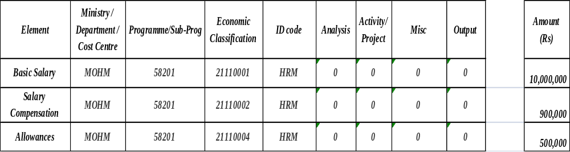

    - Illustration 2 - Reallocation Warrant within same Sub-Programme
Suppose the Ministry of Health and Quality of Life decides to make a virement from one item to another item within the same sub-programme of the Ministry.

Programme 582 : Curative Services

Sub-programme 58201: Hospital Services and High Tech Medicine

An amount of Rs 50,000 is being transferred from item Travelling to item Overtime within the same sub-programme.

The data will be captured as follows:

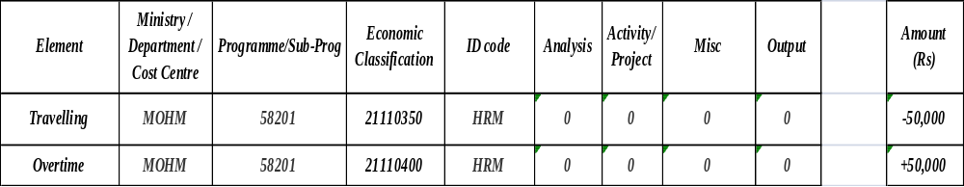

    - Illustration 3 - Amount earmarked for specific project
Suppose the Ministry of Health and Quality of Life wants to earmark an amount of money for a specific project from its budget. The data would be captured in such a way as to help the Ministry to retrieve the information in a timely manner.

Programme 582 : Curative Services

Sub-programme 58201: Hospital Services and High Tech Medicine

- An amount of Rs 50 m has been provided for that program under item ‘3122801 - Acquisition of High Tech and other Medical Equipment’

- An amount of Rs10 m is being earmarked for the project ‘Accident & Emergency Dept at SSRN Hospital’ (Project code F0016). The transaction involves reducing funds available under the item ‘31122801’ by Rs 10 m and setting aside this amount for subsequent expenditure on project F0016.

- After the entry, the available balance under the item will decrease by Rs 10 m

The data will be captured as follows:

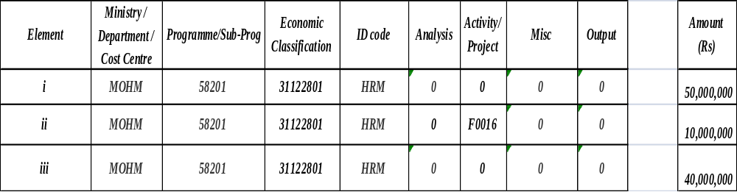

    - Illustration 4 - Issue of Departmental Warrant
Suppose the Ministry of Health and Quality of Life issues a departmental warrant to the Ministry of Social Security, National Solidarity, and Senior Citizens Welfare & Reform Institution .The issuing Ministry will capture the ID code of the Ministry of the receiving department to enable the latter to use the fund of the issuing department.

Programme 582 : Curative Services

Sub-programme 58201: Hospital Services and High Tech Medicine

MOH Region 1 issues a Departmental Warrant to the Ministry of Social Security (MOS) under item Personal Emoluments for an amount of Rs 5,000 – broken down into: - Acting allowance : Rs 3,000 , Disturbance allowance : Rs 2,000

The data will be captured as follows:

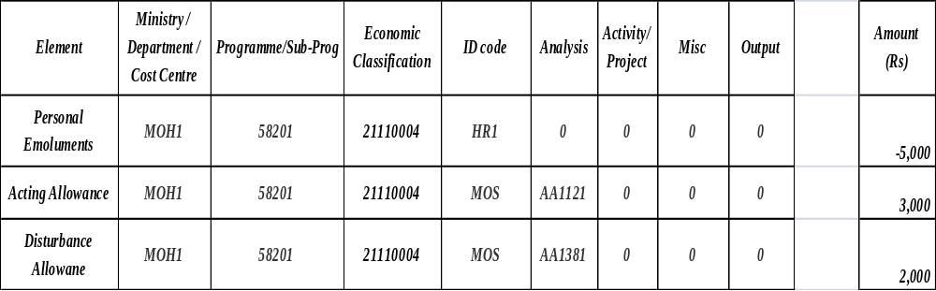

    - Illustration 5 – Payments
Suppose the Ministry of Health and Quality of Life has 3 types of payment, one of a recurrent nature and two of capital nature. The 3 transactions are as follows:

Programme 582 : Curative Services

Sub-programme 58201: Hospital Services and High Tech Medicine

Example 1:
Payment of mileage allowance

Example 2:
Payment to contractors for the Construction of Maternity and Child Health services at SSRN Hospital (PSIP code F0105)

Example 3:
Purchase of High Tech Equipment for SSRN Hospital (PSIP Code F0167)

The data will be captured as follows:

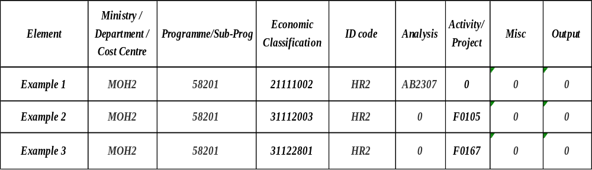

    - Illustration 6 - Use of Miscellaneous segment
Suppose the Ministry of Foreign Affairs and Cooperation wants to keep information on payment made to the Ambassador in Washington.

Programme 382 : Foreign Relations

SubProgramme 38202: Support by Mauritius Overseas Missions

Payment of children educational supplement to Ambassador in Washington

The information will be captured as follows:

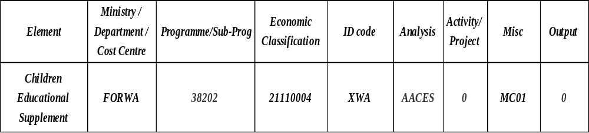

    - Illustration 7 - Revenue collection
The three examples below show how the capturing of data on revenue is carried out :

Example 1:
Receipt in respect of Motor vehicle licenses

Example 2:
Income Tax deduction from payroll - PAYE from Ministry of Education and Human Resources

Example 3:
Tax Deduction at Source for Ministry of Finance in connection with Rent payment

The table below illustrates how the data will be captured:

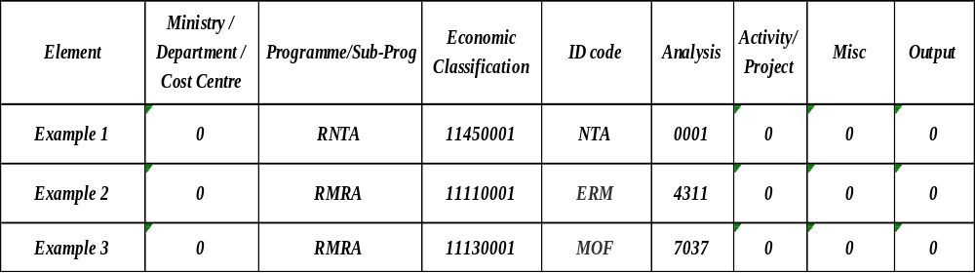

    - Illustration 8 - Below the line Accounts
Alpha codes, to be captured under the ‘Programme/Sub-programme’ segment ,have been assigned to below-the-line accounts to facilitate the capture of data in respect thereof (refer to Annex II part 2 for the relevant codes)

Example 1:
Amount deducted from salary on behalf of Mauritius Union Assurance and credited to Deposit Account - Sundries

Example 2:
Amount refunded by Mr.M in connection with overpayment and credited to Advance Account 'P"

Example 3:
Amount refunded by Mr X in connection with Advance motor car.

The table below illustrates how the data will be captured:
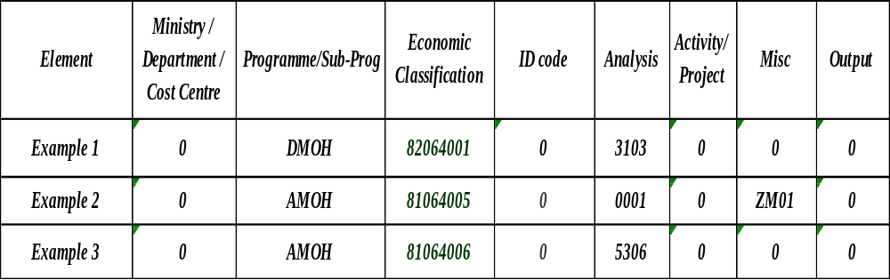

In example 2, the miscellaneous segment is being used to capture the name of the officer concerned .Z stands for ‘Advance a\c ‘P’ while ‘M01’ is the code assigned to the specific officer concerned.

    - Illustration 9 (Activity)
Suppose the Ministry of Health and Quality of Life has the following activity under Programme 582 and Sub-programme 58201:

Activity : “Conference on HIV Diseases”

Programme 582 : Curative Services

Sub-programme 58201: Hospital Services and High Tech Medicines

This activity will encompass several items of expenditure, for example

(i) Rent of Conference Centre

(ii) Purchase of Stationary

(iii) Provision of Refreshments

(iv) Refund of Travelling

(v) Payment of Overtime to support staff

The table below illustrates how the data will be captured

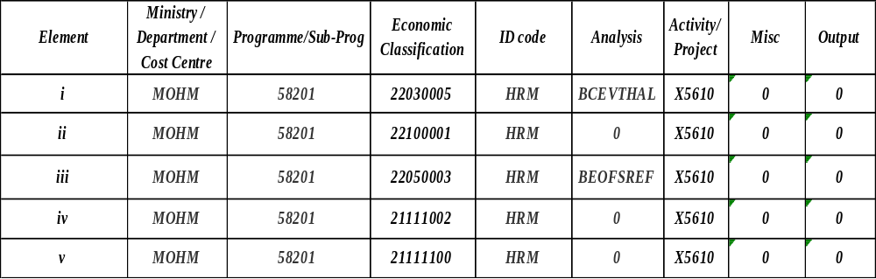

    - Illustration 10 (Issue of Imprest)

Suppose a new imprest warrant has been issued in favour of an Officer of the Ministry of Industry, Scientific & Research to meet petty expenses.

Issue of Imprest Warrant for Rs 3,000 to Officer Y to meet petty expenses

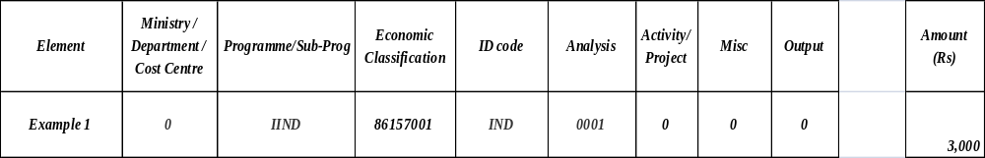

  - Tas Codes Table
To facilitate the preparation of payment vouchers and the input thereof into TAS, it is strongly recommended that users prepare TAS codes tables at the start of every financial year.

The TAS code Table in respect of the Treasury is given at Annex VII. As shown in the table, alias codes have also been developed. Although users will have to develop their own alias codes, they may be guided by the codes used by the Treasury. The table is expected to be on Excel format to enable copying to the appropriate segment on payment vouchers. The latter process is explained in the following section.

  - Preparation Of Payment Voucher
It is recognized that a PBB and GFS compliant COA requires the capture of more data and thus a longer input code, especially in respect of expenses. The preparation of payment vouchers might be more time consuming if the manual practice is pursued. Thus, it is recommended that all users use the MS Office tools to prepare the payment vouchers.

In the example given below, the process is explained.

Users may use the data validation icon to develop drop down lists in respect of each cell in the payment voucher form. The use of drop down lists will facilitate the recording of codes and other information on PVs such as supplier name, address, number, Bank name and bank account number.
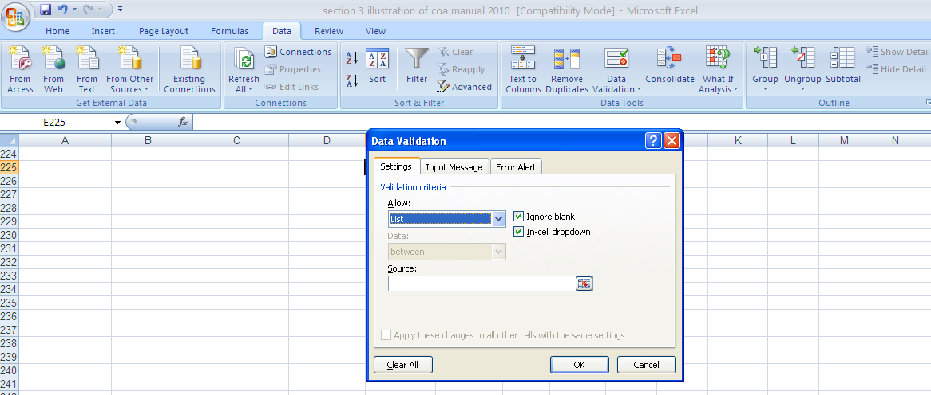
Select the range of values from separate sheet
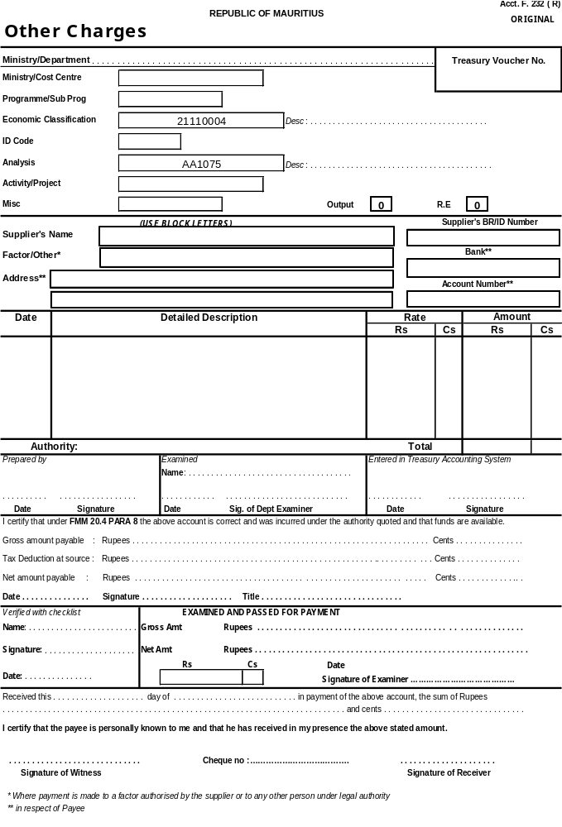
Click and select the appropriate value

Section 4 - Chart of Accounts Procedures

Approved by the Financial Secretary on:
Effective Date: | 01 Jul 2008

  - Overview
4.1.1 Purpose
The purpose of this document is to detail the procedures relating to the creation and maintenance of government’s Chart of Accounts.

4.1.2 Coverage
The Chart of Accounts procedure applies to all staff involved in requesting new classifications, responsibility centres, projects/category codes, analysis codes and other codes and/or amendment and/or closure of these.

  - Procedures and Guidelines
4.2.1 General Information
I Accounting information is organised in the Treasury Accounting System by using a Chart of Accounts – a series of individual values, which, in combination, describe a specific accounting activity.

II The Chart of Accounts structure consists of eight segments as indicated below:

Purpose | Organisational Classification | Programme Classification | Economic Classification | Spending Authority | Management Information System | Management Information System | Management Information System | Management Information System
Segment values | Ministry / Department / Cost Centre | Programme/Sub-Programme | Economic Classification | ID code | Analysis | Activity/ Project | Misc | Output

III Flex Fields values must be created in the Oracle Financials General Ledger before they can be used in a transaction.

IV Flex Fields Tree Structures are used to create hierarchical structures, which visually represent a set of summarisation rules for a particular Flex Field. For example, reporting and organisation structures for responsibility centres. Requests to change responsibility structures must be approved by the Treasury.

4.2.2 Chart of Accounts Maintenance
The overall responsibility for the Chart of Accounts rests with the Treasury. This includes the approval of all segments values.

Requests for changes and additions to the Chart should be submitted via requests forms available at the Treasury.

The Systems Team of the Treasury will be responsible for the establishment of approved segment values in TAS System and the establishment and maintenance of associated accounting and system (e.g. cross-validation) rules.

The Chart of Accounts working group will review the usage of the Chart Segments and values annually. Rarely used values may be closed to maintain efficiency of the Chart.

4.2.3 Responsibilities
4.2.3.1 Users

1. Input and Verification of Estimates in TAS
~ Input and verification of Reallocation certificates and Departmental Warrants.

2. Maintaining the Document Sequence for AP, GL and (AR for Self Accounting)

3. Maintaining Invoice Templates.

4. Input and verification of Invoices and Journals with respective listings after ensuring availability of funds on line or their reports available in FSG.

5. Approval and Earmarking
- For Non self Accounting
~ Approval of Earmarking and Payrolls before submission to Treasury.

- For Self Accounting
~ Approval and Payment Processing

6. Verification of items in Detailed Trial Balance on last working day and ensuring Journal Entries for discrepancies have been performed in the same month.

7. Ensuring posting of all Journal Entries before closing of the month and cancellation of incomplete ones.

8. Reconciliation of Expenditure, Below the Line ledgers and Cash Book with Trial Balance.

9. Submission of certificates to the Treasury.

10. Ensuring that no approval of invoices and posting of Journal Entries is done in the last working day of the month.

11. Printing of Expenditure and Below the Line ledgers after 3 p.m.

12. Officer in Charge should ensure that incoming officer is conversant with the system before request is made to remove/assign responsibilities to the above.

4.2.3.2 Treasury Systems Team

A. Opening of Year
- Preparation of monthly and weekly accounting period calendars

- Updating of organisational classification codes

- Monitoring input of expenditure estimates into Treasury Accounting System (TAS)

- Posting of Revenue Items to General Ledger

5. Ensuring cancellation of incomplete entries into TAS
B. General
- Transfer of receipts and payments data to General Ledger (GL)

- Uploading bank data on encashed cheques into TAS and posting to cash accounts of ministries/ departments concerned

- Adjustment of budgetary provisions upon receipt of reallocation and contingencies virement warrants

- Assignment and removal of user's responsibilities

- Reviewing monthly reconciliation certificates

- Updating supplier: Business Registration Number (BRN), TAN Number, Bank Account and deactivate unused suppliers

- Creation of items & Codes in respect of revenue and expenditure ( as requested by Ministry of Finance),

- Deposits, Advances, Investments and cost centres as requested by ministries/departments

- Creation and correction of payroll templates

- Checking whether ministries/ departments have approved their payroll

- Cleaning of data in invoice batches and journals created but not used

- Maintenance of summary accounts

- Preparation of Financial Reports (as requested by Ministries /Departments)

- Opening of month in Accounts Payables, Accounts Receivables and General Ledger modules

- Checking journal entries

- Reconciliation of revenue ledger with Trial Balance

C. Closing of year
- Verification of journal entries

- Input of retrospective reallocations

- Closing of Accounts Receivables and General Ledger modules

- Preparation of accounts and annual abstracts for audit purposes

4.2.3.3 DBA Section

A. Troubleshooting
1. Hardware Problem (Servers, PCs, Printers)

- Software Problem (Database, Oracle Financial Apps, Software installed on PCs)

- Network Problem

- Security – ensure client PCs have latest update of anti-virus and manage Slave-server

B. Day to Day Running
- 1. Verifying tables paces usage/disk usage

- Verifying log files on servers

- Performing backups

C. System Maintenance
1. Contacting SIL for malfunctioning on Systems

2. Installing of Netscape communicator and J-Initiator to enable access to TAS

D. Contingency Measures
1. Cyclone switch on servers and start up database with assistance of SIL after preliminary tests

2. Data corruption – verify related log files and recover database with assistance of SIL
3. Disk Crash- verify related parameters/log files and contact SIL for replacing disk.

- To verify that disks are mirrored.

Glossary

Activity: Actions taken or work performed through which inputs, such as funds, technical assistance and other types of resources are mobilized to produce specific outputs. In essence, activities describe “what we do”. E.g provide training, organising awareness campaigns, etc.

Acquisition: It includes purchases of land, including improvements works like demolition of buildings or leveling etc. of an acquired land.

Beneficiaries: The individuals, groups, or organizations, whether targeted or not, that benefit, directly or indirectly, from the development intervention.

Capital Projects: The procurement of new infrastructure / facilities or significant, long-term renewal improvements to existing infrastructure / facilities. E.g construction of new buildings, hospitals, roads, power plants, water reservoirs and other infrastructure items; replacement of old facilities; renovation of existing facilities; acquisition of new facilities; or purchase of equipment. Capital projects normally are large, nonrecurring expenditures that involve multiyear funding, have a useful life greater than five years, are based on a comprehensive needs assessment, meet an essential public purpose, and require public accountability for funds.

Classification Of Functions Of Government: A detailed classification of the functions or socio-economic objectives of the Government that the latter aims to achieve through various kinds of outlays. Examples are education, health, environment protection, etc.

Compensation Of Employees: The total remuneration payable to Government employees in return for work performed. It includes basic salary, salary compensation, extra remuneration, allowances, extra assistance, cash in lieu of sick leave, transfer grant, facilities allowance to honourable members, end of year bonus, travelling & transport, overtime, passage benefits and allowance in lieu of passages.

Construction Project: A single undertaking involving construction of one or more facilities. Included in the project are: all work necessary to accomplish a specific purpose and produce a complete and usable new structure; the associated architectural and other technical services; the equipment installed and made part of the facility; and site development and improvements

Corporations: Legal entities created for the purpose of producing goods or services for the market.

Cost: The price paid or to be paid.

Cost Centre: An area of activity identified in the “Chart of Accounts” for which a manager is held accountable for financial management.

Economic Classification Of Expense: The types of expenses incurred for the Government activities. For example, compensation of employees, use of goods and services, social benefits, etc.

Economically Significant Prices: Prices that have a significant influence on the amounts the producers are willing to supply and on the amounts purchasers wish to buy.

Efficiency: A measure of how economically resources/inputs (funds, expertise, time, etc.) are converted to results.

Equipment: A tangible resource of a permanent or long-term nature used in an operation or activity and is an integral part of a facility.

Expenditure: All non-repayable and non-repaying payments by government, whether requited or unrequited and whether for current and capital purposes.

Expenses: Reductions in assets or increase in liabilities. Expenses are the relevant notion in full accrual accounting.

Financial Corporations: Entities engaged in providing financial services for the market.

Gender: The concept of gender refers to the distinction between men and women, to the nature of the relationship (particularly of power) and to the differences they give rise to between men and women. It also refers to the differences among women and men, in the sense that each category, although identical in terms of sex, is differentiated in terms of age, ethnicity, location as well as socioeconomic variables, such as income, marital status, education. As a result, the nature of gender relations is dynamic. It varies over time and in different contexts and is affected by budget decisions.

Government units are institutional units that carry out the functions of government as their primary activity.

Grants: Voluntary current or capital transfers from one Government Unit to another or to an international organization:
- Social benefits are defined as transfers in cash or in kind to protect the entire population or specific segments of it against certain social risks;
- Transfers to non-profit institutions include transfers to aided schools, charitable institutions, Religious bodies, local organisations, etc;
- Transfers to households comprise of compensation to net fishermen; grant to Oriental Language Teachers; scholarships to students;
- Transfers to non-financial public corporations are payable to Enterprises Mauritius, Central Electricity Board, National Housing Development Co. Ltd, among others;
- Transfers to financial public corporations include transfers to Development Bank of Mauritius and Mauritius Housing Company Ltd;
- Transfers to private enterprises are meant for accompanying measures to Small and medium Enterprises (SMEs).etc.

Impact: Positive and negative, primary and secondary long-term effects produced by a development intervention, directly or indirectly, intended or unintended. The impact is the outcome or benefit to the public due to the priority objective(s) being met.

Improvement: All work necessary to produce a complete and usable change to an existing facility or structure, including the associated architectural and other technical services, the fixed equipment installed and made part of the facility or structure, and site development.

Indicator: Quantitative or qualitative factor or variable that provides a simple and reliable means to measure achievement, to reflect the changes connected to an intervention, or to help assess the performance of a development actor.

Inputs: All the resources that contribute to the production and delivery of outputs. Inputs are “what we use to do the work”. They include finances, personnel, equipment, buildings, etc. E.g money, staff and staff time, facilities, supplies, etc.

International Organisations: Organisations in which Mauritius is a member and/or has dealings with them. Examples are African Development Bank, Common Market for Eastern and Southern Africa (COMESA), International Finance Corporation, Multinational Investment Guarantee Agency, International Bank for Reconstruction and Development (IBRD), etc.

Investment Project: A development intervention relating to acquisition and or preservation of non-financial assets for meeting defined objectives and consisting of a set of interrelated activities to be carried out within a specified budget and a time-schedule.

Market Establishments: Units/Divisions of Public Corporations situated at single location that sell or dispose their produce/output from their principal activity at economically significant prices.

Medium Term Framework: The Government of Mauritius defines its Medium Term Framework (MTF) with two primary objectives: i) Improving macroeconomic balance by developing consistent and realistic estimates of available resources; and ii) Restructuring and rationalizing resource allocation so that priority areas receive adequate funding. In defining a MTF as an operational concept, it is important to distinguish three levels of development:
- Medium Term Fiscal Framework (MTFF): It contains a statement of fiscal policy objectives and a set of integrated medium-term macroeconomic and fiscal targets and projections.
- Medium Term Budget Framework (MTBF): The objective of an MTBF is to allocate resources to the country’s strategic priorities and ensure that these allocations are consistent with overall fiscal objectives.
- Medium Term Expenditure Framework (MTEF): The main characteristics of an effective MTEF should be as follows: i) Limited resources should be allocated to priorities areas; ii) Ministries should have some predictability in the flow of resources; iii) Ministries only plan their activities on the basis of a “3-fiscal year rolling PBB Statement” for delivering agreed outputs measured with verifiable performance indicators, and achieving targets; and iv) Increased accountability (officially-designated programme managers should gradually be held responsible for the performance of the activities they manage) and increased transparency (it should be possible to see where funds are being used and the impact of these expenditures

Monitoring: A continuing function that uses systematic collection of data on specified indicators to provide management and the main stakeholders of an ongoing development intervention with indications of the extent of progress and achievement of objectives and progress in the use of allocated funds.

Non-Financial Corporations: Entities created for the purpose of producing goods and non-financial services for the market.

Objective: The end result that the Ministry commits to achieve through the delivery of a programme or sub-programme.

Outcomes: The likely or achieved short-term and medium-term impacts of an activity’s or intervention’s outputs.

Outputs: The products, capital goods and services which result from a development intervention; it also includes changes resulting from the intervention which are relevant to the achievement of outcomes.
- Indirect Outputs: internal clients - Services which are supplied to an internal user rather than to the external client, e.g. IT support services delivered by the ministry in charge of IT to other ministries.
- Direct Outputs: external clients - e.g. number of girls and boys’ inoculations.

Policy: Principle of action proposed or adopted by a Government. Policies include a set of measures to translate the objectives of the Government into action.

Process: The means by which inputs are transformed into outputs.

Programme / Sub-Programme:
- Programme: A group of activities or interventions intended to contribute to a common set of outcomes, priority objectives and outputs that are verifiable, consisting of a defined target and a given budget including staffing and other necessary resources.
- Sub-Programme: The programme hierarchy which breaks programmes into sub-programmes and which in turn break into activities or interventions and is designed to achieve at least one priority objective.

Programme Appropriation: The appropriation of funds in the budget on the basis of programmes .

Programme-Based Budgeting (PBB): PBB is the budgeting system that, contrary to conventional budgeting, describes and gives the detailed costs of every programme/sub-programme that is to be carried out in a budget. The focus is changed from an input-based annual activity to a result based multi-annual exercise that clearly links the funds appropriated by the National Assembly to outputs (the goods and services produced by Government) and

outcomes (changes that the public perceives in their daily life, like for example, faster travel on our roads).

Project: A group of activities concerned with delivering a defined capability based upon an agreed schedule and budget.

PSIP: Public Sector Investment Programme

Quasi-corporations: Entities that are not incorporated or otherwise legally established, but which function as if they were corporations.

Result: The output, outcome or impact (intended or unintended, positive and/or negative) of a development intervention.

Social Benefits: Transfers in cash or in kind to protect the entire population or specific segments of it against certain social risks.

Social Contributions: Receipts either from employers on behalf of their employees or from employees, self-employed, or non-self employed persons on their own behalf that secure entitlement to social benefits for the contributors, their dependents, or their survivors. These contributions may be voluntary or compulsory

Social Risk: An event or circumstance that may adversely affect the welfare of households concerned either by diminishing their resources or by reducing their incomes.

Specific Objective: An outcome target. The intended physical, financial, institutional, social, environmental, or other development results to which a sub-programme is expected to contribute.

Subsidies: Payments that Government makes to public and private enterprises on the basis of the levels of their production activities or the quantities/values of goods/services they produce, sell, export or import.

Transfers: Sums of money changing hand from one person to another or from one organisation to another or from Government to individuals/statutory bodies/corporations or vice versa. Subsidies and grants given by the Government are regarded as transfers.

Use Of Goods And Services: All items of expenses incurred by the Government in providing goods and services to the public and community at large.

Virement: Reallocation of funds within a Ministry/Department: (i) from an item of expenditure within a sub-programme or programme; or (ii) from an item of expenditure in respect of a sub-programme or programme to another item of expenditure in respect of another sub-programme or programme. Virement also includes a reallocation of funds: (i) from a Ministry/Department to another Ministry/Department in respect of expenditure relating to acquisition of assets (expenditure categories 31 and 32); and (ii) from Programme 989 “Contingencies and Reserves”(Refer to Financial Instructions No 1 of 2008 and No of 2009).

Voluntary Transfers: Gifts and donations received from individuals, private non-profit institutions, non-government foundations, corporations, and any other source.

