Project Data
Project Name:
Location:
Implementing Agency:
Project Value (PV): (Rs Million)
Construction Period:
Evaluation Date:
Project Rationale
Description of the problem or need the project addressed.
Objectives of the project.
Strategic relevance (e.g., alignment with national/regional plans).
Evaluation Methodology
Evaluation Objectives
Assess project relevance, effectiveness, efficiency, sustainability, and impact.
Methodological Approach
Data collection methods (site visits, surveys, interviews, secondary data).
Tools and indicators used.
Baseline v/s Actual comparisons (if available).
Findings
Effectiveness
- To what extent were the original objectives achieved?
- Output indicators/KPI as per budget estimates (e.g., km of roads built, capacity increased).
- Outcome indicators/KPI as per budget estimates (e.g., traffic flow improvement, access to clean water).
Efficiency
- Actual vs budgeted amounts (cost overruns?).
- Project duration vs schedule duration of project (delays?).
- Procurement and project management performance.(Issues encountered?)

Impact
- Economic impact (e.g., productivity, job creation).
- Social impact (e.g., health, education access).
- Environmental impact (e.g., emissions, biodiversity).
- Distributional effects (e.g., gender, vulnerable groups).
Sustainability
- Institutional sustainability (ownership, local capacity).
- Financial sustainability (O&M funding).
- Environmental sustainability (e.g., mitigation measures in place).
Cross-Cutting Issues
- Gender Equality: to what extent were gender equality aspects implemented?
- Climate Resilience: Was the project sufficiently designed for climate risks?
- Innovation & Technology: Any notable innovations adopted?
Lessons Learned
- Key insights into what worked and what didn’t.
- Transferability of lessons to other projects or sectors.
Conclusions and Recommendations
Overall Assessment
Brief summary using a scoring system or traffic light indicators
(e.g., relevance: high, effectiveness: medium, etc.)
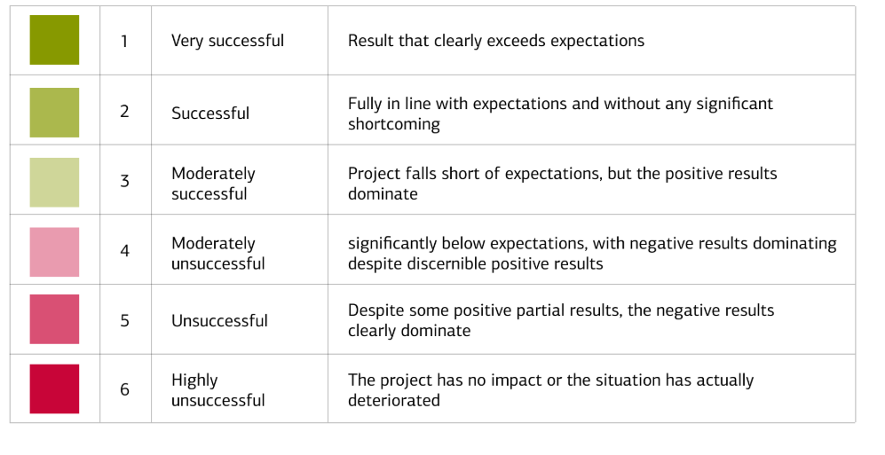
Rating scale 1: very successful, result that clearly exceeds expectations
Rating scale 2: successful: fully in line with expectations and without any shortcoming

Rating scale 3: moderately successful: project falls short of expectations, but the positive results dominate
Rating scale 4: moderately unsuccessful, significantly below expectations, with negative results dominating despite discernible positive results
Rating scale 5: unsuccessful: despite some positive partial results, the negative results clearly dominate
Rating scale 6: highly unsuccessful: the project has no impact or the situation has actually deteriorated
Main Findings:
Achievement of objectives
Cost-effectiveness
Socio-economic impact
Environmental outcomes
Lessons learned and recommendations
Recommendations
- For future similar projects.
- For ongoing operation and maintenance.
- For institutional or policy improvements.
Annexes
- Detailed results matrix (planned vs actual outputs/outcomes).
- Maps and technical drawings.
- Survey instruments used.
- Financial and timeline tables.
Post Operation Report Certified by:
 | Officer in charge of the Implementing Agency | Supervising Officer of the Parent Ministry
Full Name
Designation
Signature
Date

